How to use Github in Visual studio 2019

- Install Git Extension for Visual Studio
2 different methods
Method 1: In Visual Studio select Tools -> Extensions and Updates which open the window show in Figure 1. Download and install the extension, a reboot of Visual Studio was required for me.

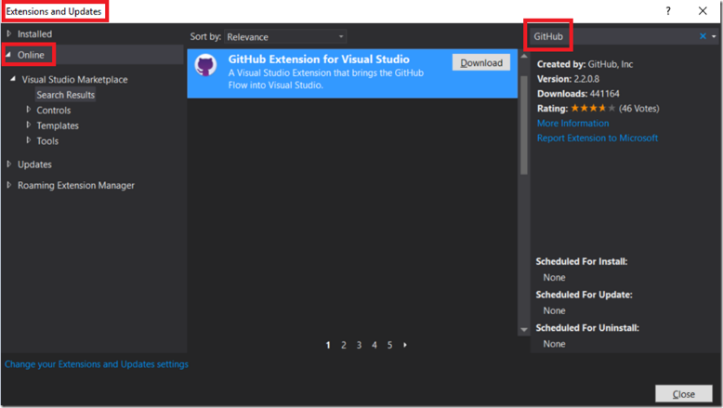
Method 2.1 : Search for visual studio installer in windows search and run the installer

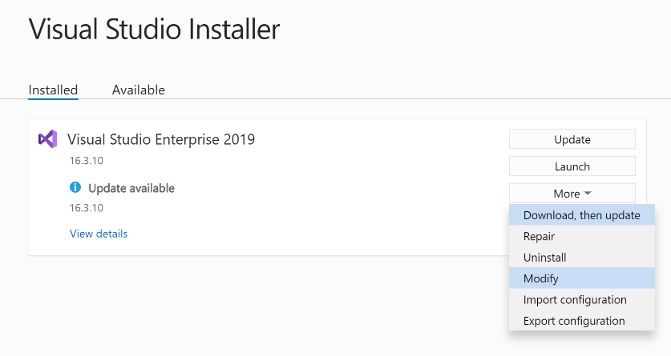
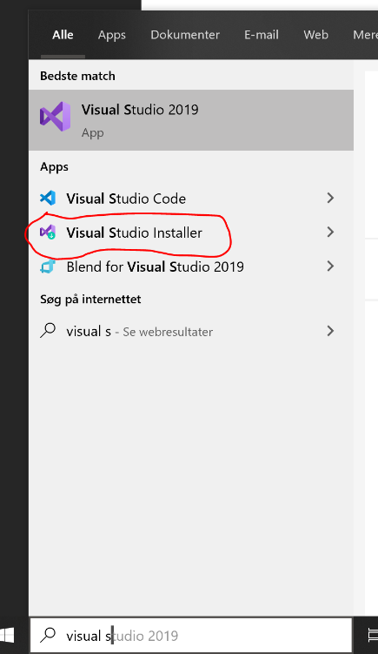
Method 2.2 Click on More -> Modify

- Click on Individual Components
- Scroll down and find Git Extension for Visual studio and set a tick mark in the box
- Click on Modify

Now run visual studio

- Open Team Explorer from View -> Team Explorer
- Click on Create under Github

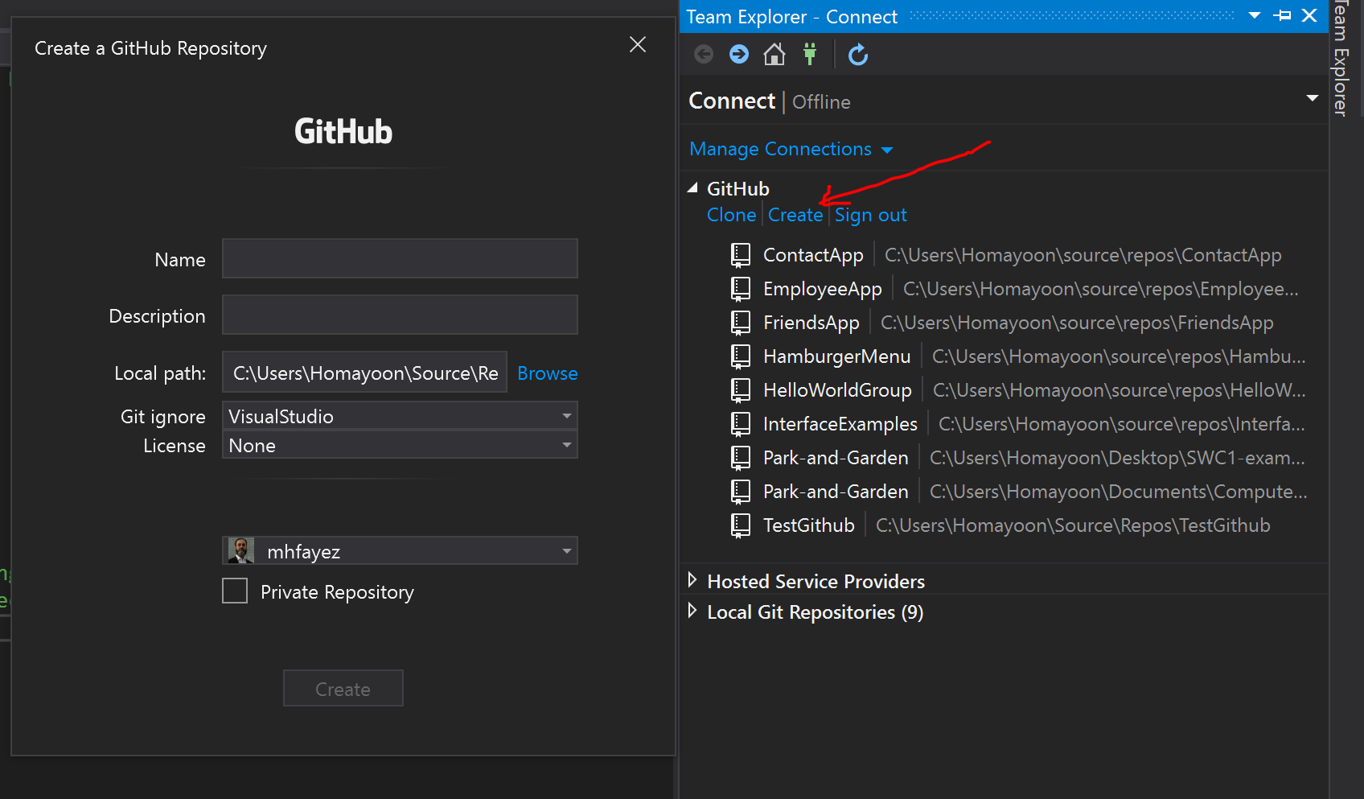

- Write the project Name, Description and Click on Create

- Now add a new Solution to this repository
- Now click on Changes

by clicking on New under solution

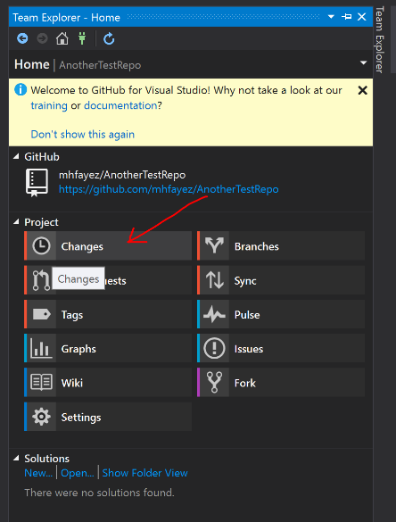
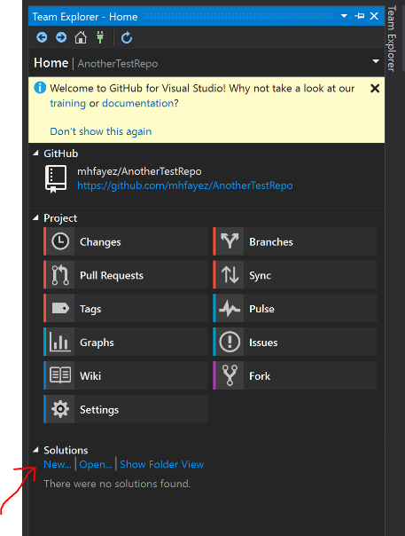

Now it’s time to commit your changes/your project/solution

2 - Now click on Sync and then push under outgoing commits
1 - Write your commit message in the box
e.g initial commit and click on Commit All

